

Year 7 Science
Biology 2 Test

SECTION 1: MULTIPLE CHOICE (1 mark each)
Circle your answer on the multiple choice answer sheet.

- Which of these is not a biotic factor in an ecosystem?
  - sunshine
  - predators
  - competition
  - commensalism

- In an ecosystem, producers are those things that
  - make their own food.
  - are eaten by consumers.
  - eat decaying material.
  - eat other organisms.

- Animals that kill and eat other animals are called
  - consumers.
  - predators.
  - omnivores.
  - scavengers.

- Which of these is another name for a first order (primary)consumer?
  - plant
  - herbivore
  - carnivore
  - omnivore

- The origin of all energy in an ecosystem is
  - plants.
  - the sun.
  - heat.
  - animals.

- Which of the following is least likely to upset the natural balance of an ecosystem?
  - Killing off or removing all of one species of plant or animal.
  - Introducing a new pest insect.
  - Climate change caused by carbon emissions and global warming.
  - Seasonal variation in temperature or rainfall.

- Desert hopping mice dig burrows and sleep in them during the day to escape the heat. When it gets cold they snuggle together to keep warm, but when it gets hot, they spread themselves out. This is an example of
  - a physiological adaptation.
  - a functional adaptation.
  - a structural adaptation.
  - a behavioural adaptation.

The next three questions refer to the following diagram

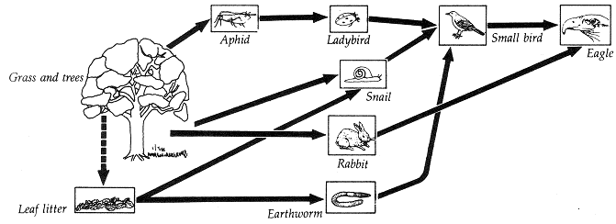

- The producer(s) in this ecosystem are
  - grass and trees.
  - leaf litter.
  - aphids, rabbits and snails.
  - eagle

- The ladybird is
  - a primary consumer.
  - a secondary consumer.
  - a tertiary consumer.
  - an omnivore.

- Which organism is a decomposer?
  - leaf litter
  - earthworm
  - eagle
  - small bird

SECTION 2: WRITTEN
Write your answers on the lined paper provided.

- Observe the diagram below of an aquarium.
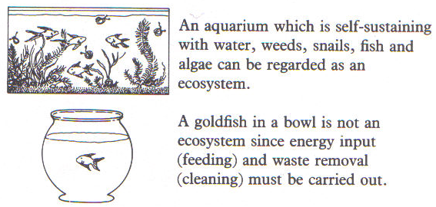

List two biotic and two abiotic factors in the aquarium ecosystem. (4)

- The diagram below describes some of the species that live in a Eucalyptus woodland ecosystem. Use the information to answer the questions below.
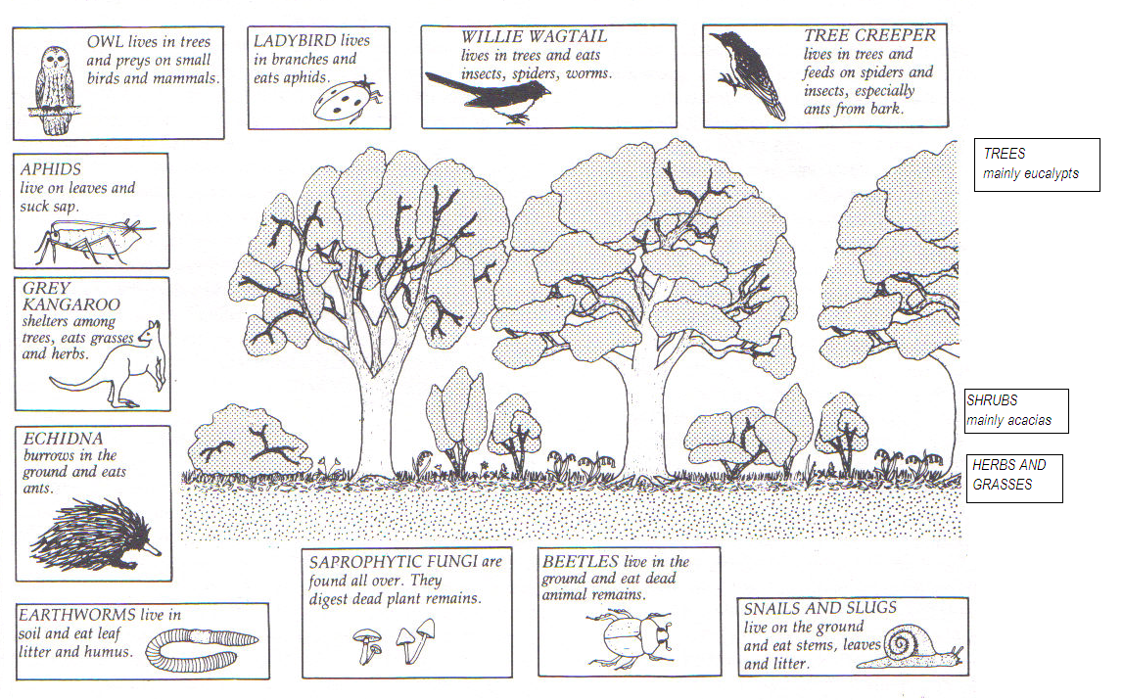
For the Eucalyptus woodland ecosystem shown above:
- Name one producer. (1)
- Name two first order (primary) consumers. (2)
- Name two decomposers. (2)
- Draw a food chain containing at least four organisms (1)
- Which animal is the highest order consumer? (1)
- What is the relationship between the aphid and the ladybird? (1)
- Describe one effect of the removal of the Eucalypt trees by logging. (1)

- Briefly describe one adaptation of Eucalypt trees that allows them to live in their environment. (2)

END OF TEST (OUT OF 25 MARKS)

